Lecturer’s name: N/A | Date: Day 1
Course: Math 6 | Unit: Operations with Positive Fractions and Decimals
Unit Duration: 10 | Lesson Duration: 1 day
TEKS: 6.2D, 6.3E | Lesson Part #1
Topic: Adding and Subtracting Decimals

Lesson objectives:
- I can estimate the sum and difference with decimals.
- I can add and subtract decimals.

Essential Questions:
- What is place value?
- How can I add and subtract decimals?

LYS Methodology
Be (Character/Values/Principles) - Educational and Financial - How does learning about addition and subtracting with decimals help me achieve curiosity, understanding and meaning?

Know (What resources are available to the student/ How can they use them) - Educational and Financial - How can these operations with decimals add to my knowledge of productivity and balance?

Do (Execute with Excellence) - Educational, Cultural, Spiritual - Understanding place value and the operations with others values help create purpose and connectedness.

Resources (Include Technology):
Instructional Input - Asynchronous
AS: Anticipatory Set (Introduction)
- Place value is very important in this lesson which is why students MUST practice in identifying place value for various examples

M: Modeling (I do) #1
- KP #1: When adding and subtracting decimals, I must line up the decimals by PLACE VALUE.
- Teacher MODELS example 1
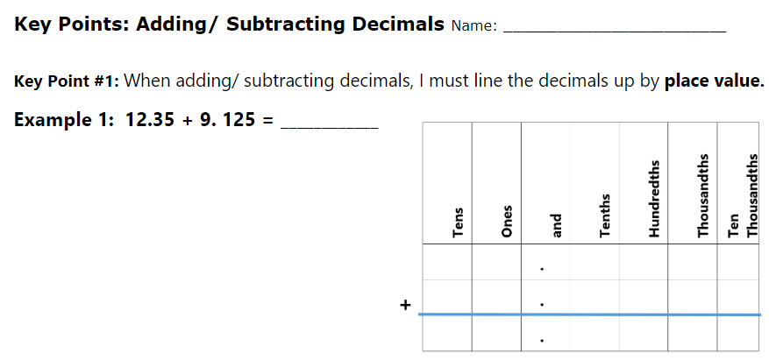
- Students COMPLETES example 2 and 3
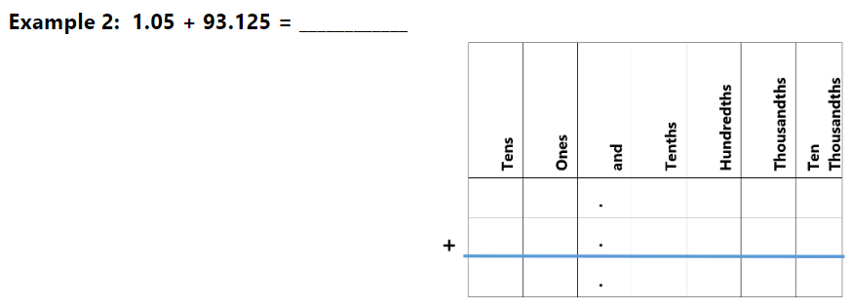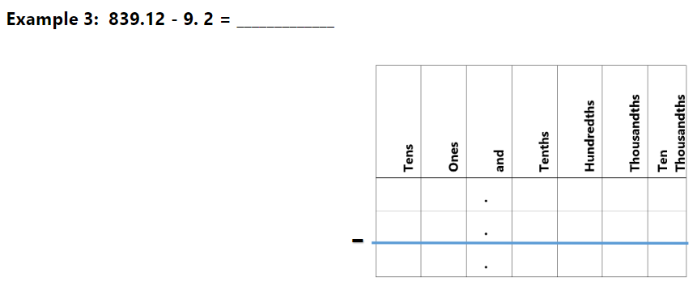

- **SAME KP #1**: When adding and subtracting decimals, I must line up the decimals by PLACE VALUE.
- Teacher MODELS example 1
- 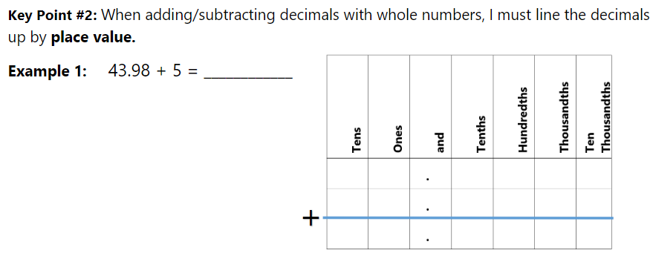
- Students COMPLETES example 2 and 3
- ​​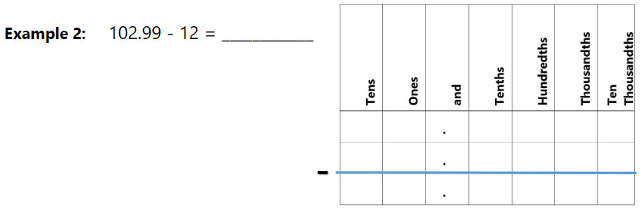 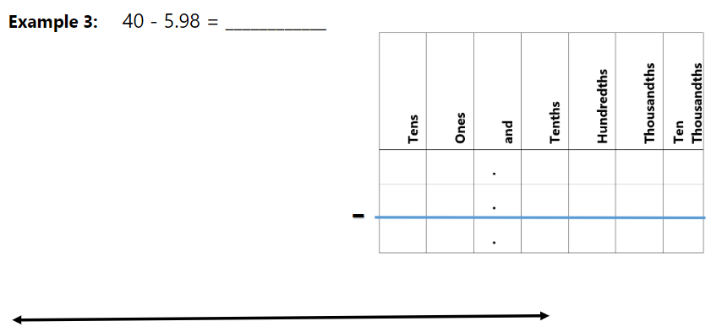
- STEPS:
  - When vertical, change them to be horizontal (up and down)
  - Line them up by place value
  - Add / Subtract

GP: Guided Practice (We do)
- 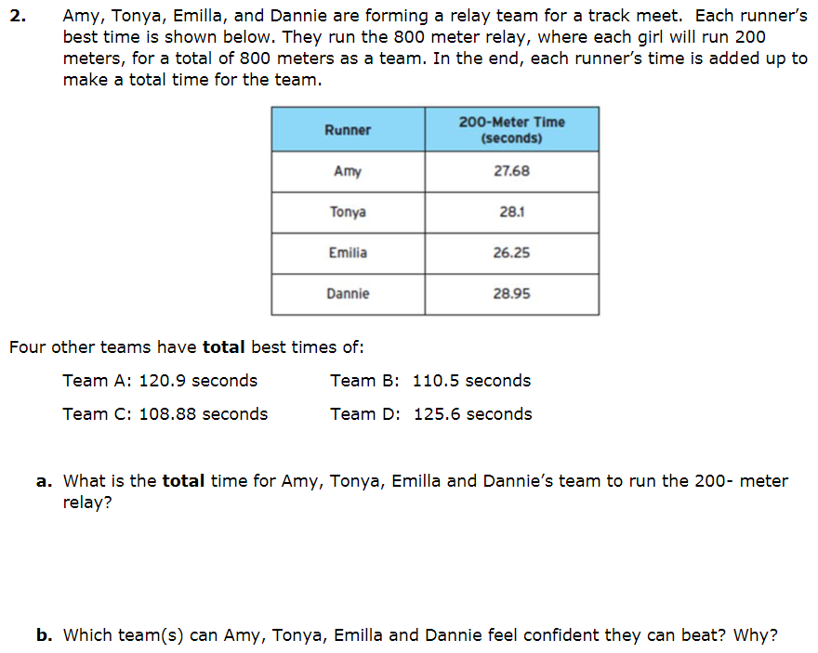
- 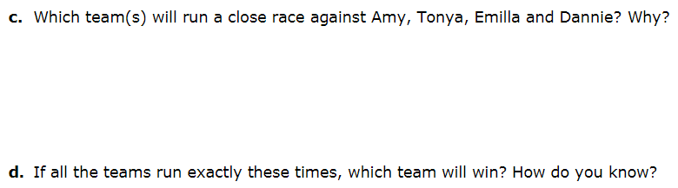

Instructional Input - Synchronous
AS: Anticipatory Set (Introduction)
- Place value is very important in this lesson which is why students MUST practice in identifying place value for various examples

M: Modeling (I do) #1
- KP #1: When adding and subtracting decimals, I must line up the decimals by PLACE VALUE.
- Teacher MODELS example 1

- Students COMPLETES example 2 and 3


- **SAME KP #1**: When adding and subtracting decimals, I must line up the decimals by PLACE VALUE.
- Teacher MODELS example 1
- 
- Students COMPLETES example 2 and 3
- ​​ 
- STEPS:
  - When vertical, change them to be horizontal (up and down)
  - Line them up by place value
  - Add / Subtract

GP: Guided Practice (We do)
- 
- 

Independent Practice/ Homework
- 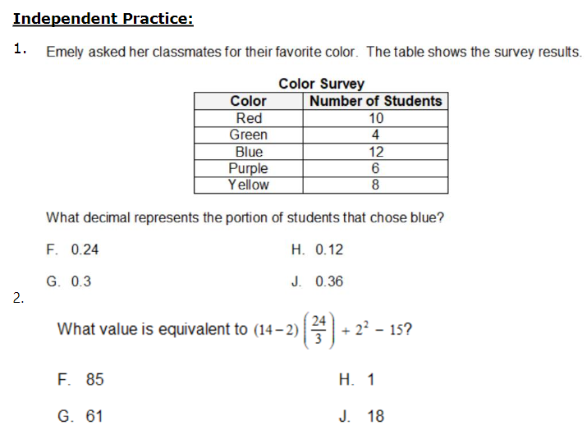
- 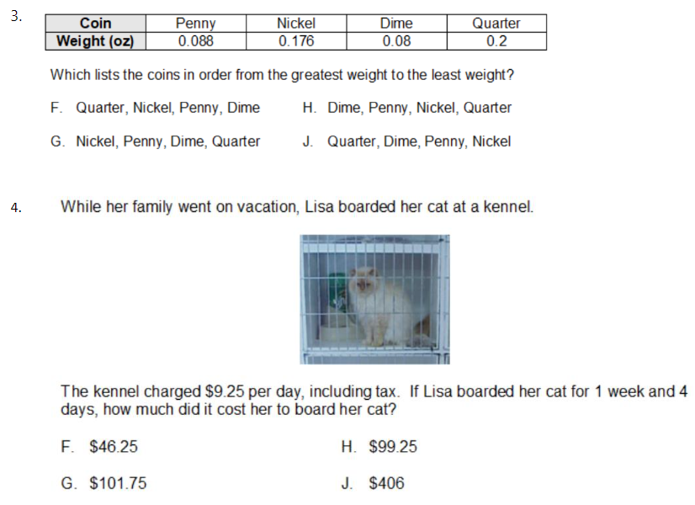
Additional Practice
- 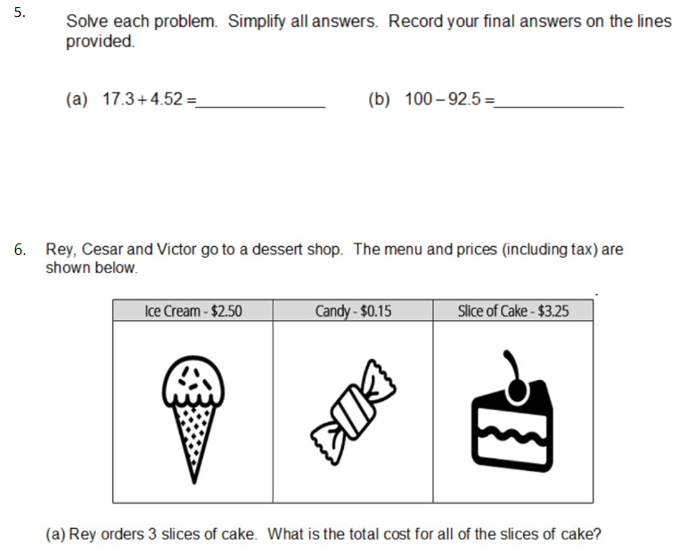

Lesson Close

“Eventually, everything connects” - Unknown

Understanding place value and the operations with others values help create purpose and connectedness. In this lesson students come to see how previous knowledge comes to pay off and is important to rely on when attempting to solve problems. This is crucial to know for life because essentially everything is connected. It may take years to understand WHY things and people come into our life, but with dedication and perseverance and responsibility, benefits will reap.

